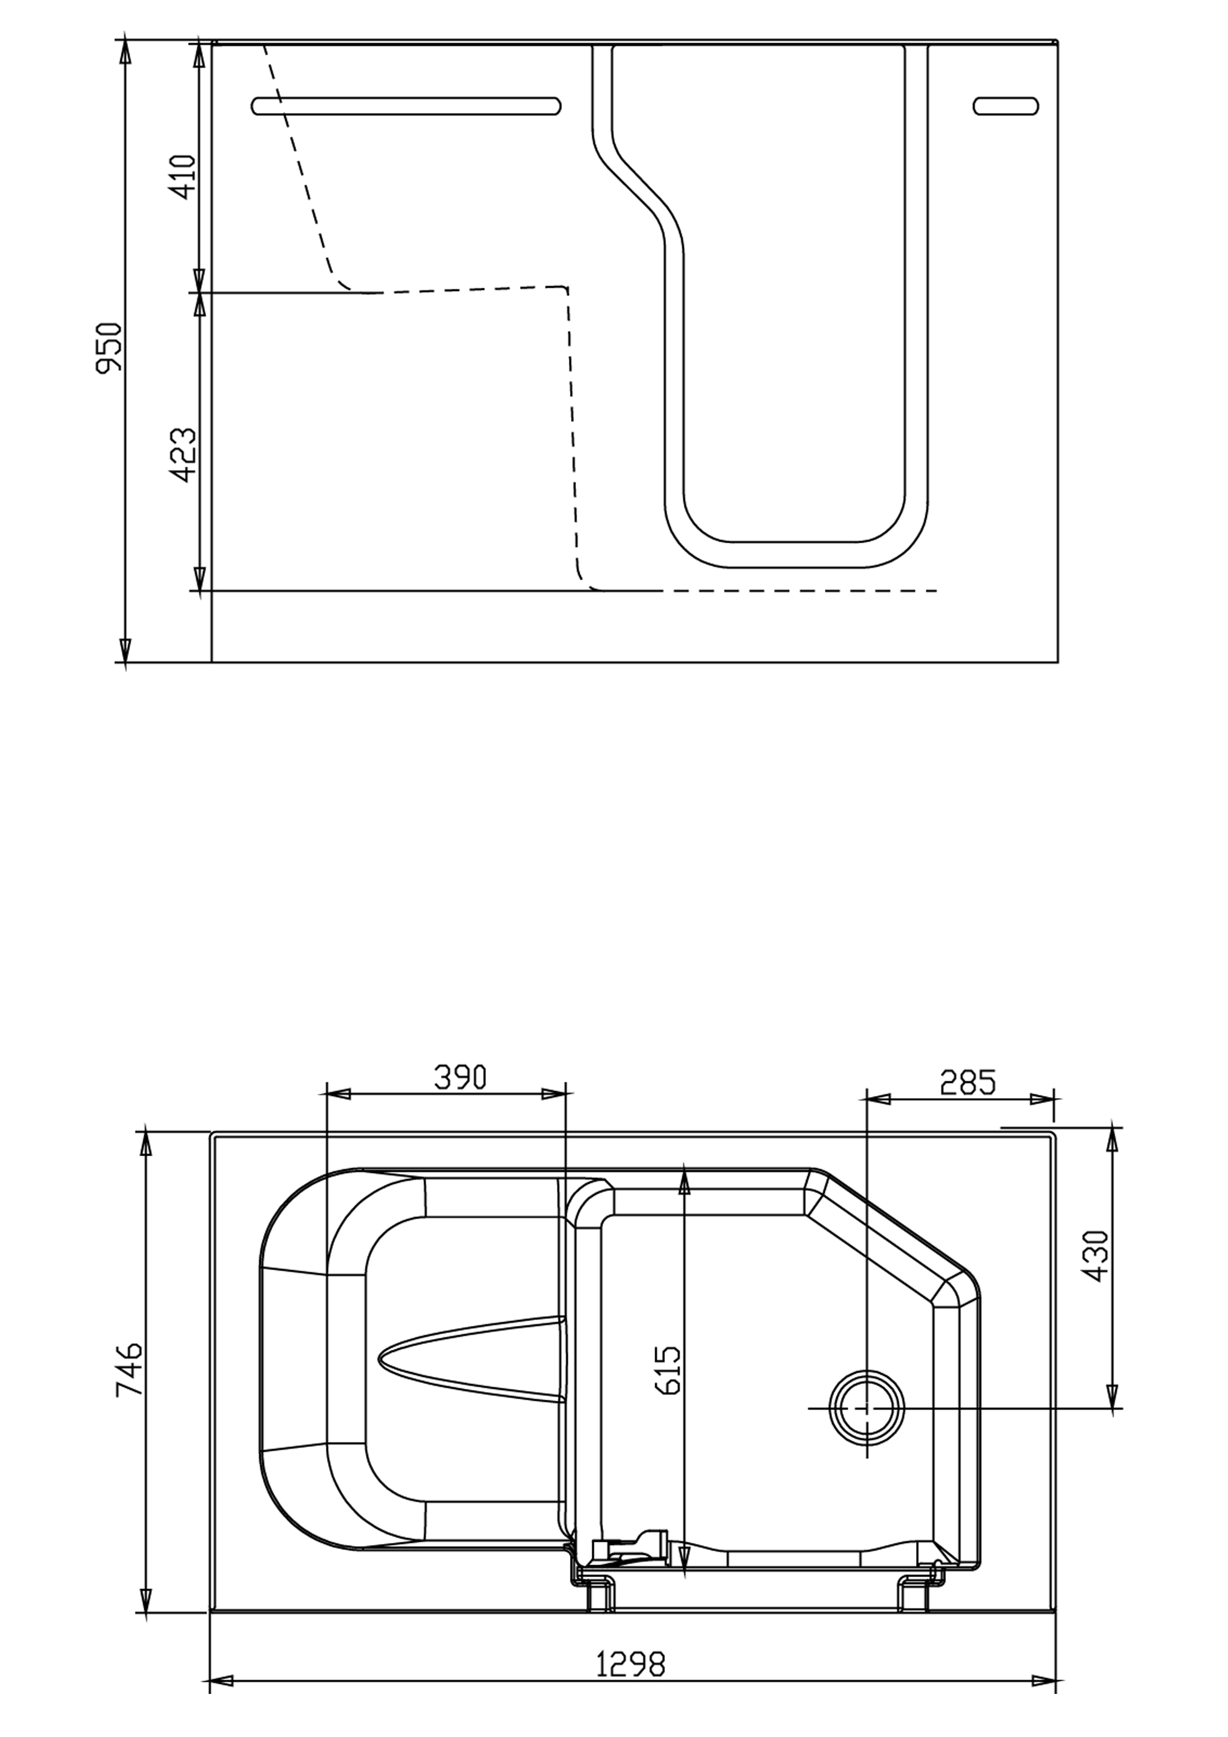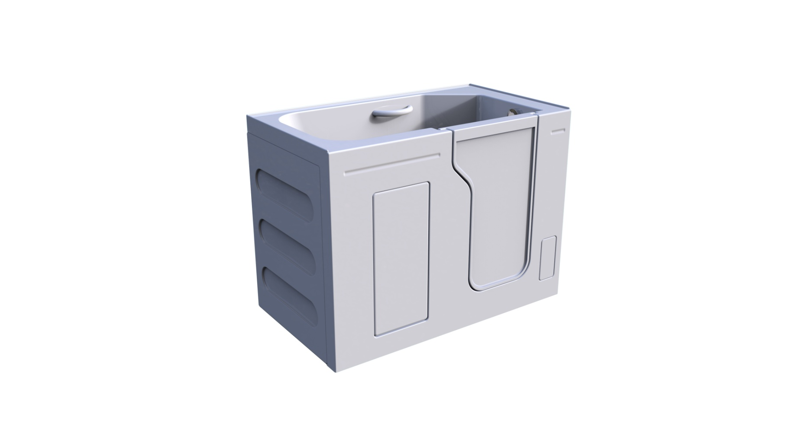

**Walk In Tub**

Stamford 75

In Swing Door

**GENERAL SPECIFICATIONS**

Dimensions …………………………...…...……….1300 x 750 x 950mm

User Weight Capacity……………....………………35 Stone/225 KG.

Operating Capacity …………………………....……….…….. 296 Litres

**Features:**

**Pop Up PVC Drain**

· Size - 2”

· Plunger with Chain

**Door**

· Opening Width - 550mm

· Patented Door System Technology

· Aluminum Door and Frame

**Acrylic Shell**

· White

· Smooth Finish

· Anti-Slip Floor

· Acrylic Surface with Fiberglass Substrate

· Grab Bar

· Stainless Steel Frame

· Includes front panel and 1 end panel

**Options**

· Left or Right Hand Door

In an effort to continually improve our product, specifications and configurations are subject to change without notice.

Will require 2 people to lift.

**Front View**

**Economy Stamford**

**Right Hand Shown**

**Top View**