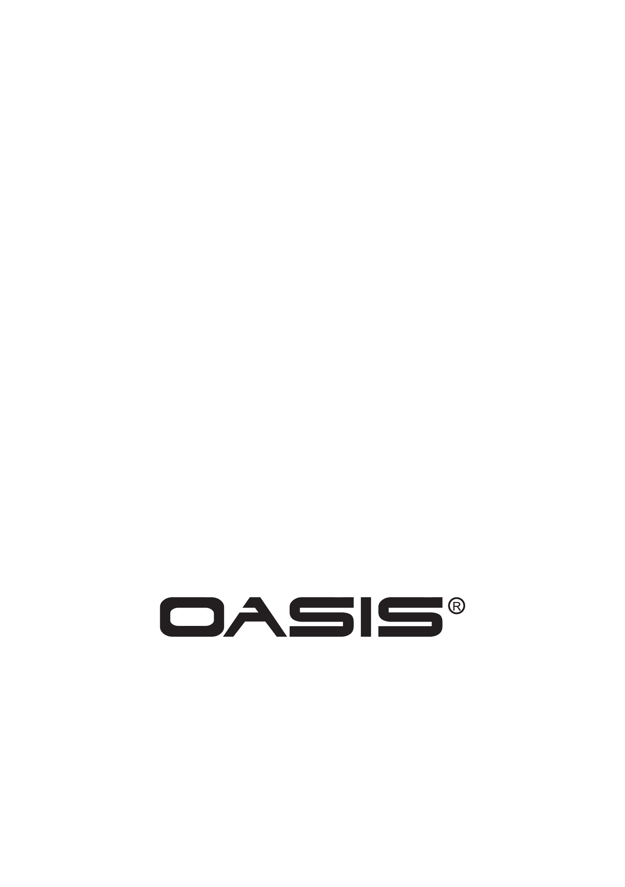

Will require 2 people to lift.

**Walk In Tub**

Serenity 66

Basic/Plus/Special

Easy Access Out Swing Door

**GENERAL SPECIFICATIONS**

Dimensions …………………………...…...……….1300 x 660 x 950mm

User Weight Capacity……………....………………35 Stone/225 KG.

Operating Capacity …………………………....……….…….. 285 Litres

**Features:**

**Pop Up PVC Drain**

· Size - 2”

· Plunger with Chain

**Door**

· Opening Width - 830mm

· Patented Door System Technology

· Aluminum Door and Frame

**Acrylic Shell**

· White

· Smooth Finish

· Anti-Slip Floor

· ADA Height Seat

· Acrylic Surface with Fiberglass Substrate

· Grab Bar

· Stainless Steel Frame

· Includes front panel and 1 end panel

**Options**

· Left or Right Hand Door

**Plus**

· Faucet, Taps and Shower

· Divergent Dual Flow

· 9 Jet Water Spa

· Headrest

**Special**

· Faucet, Taps and Shower

· Divergent Dual Flow

· 9 Jet Water Spa

· Hydrosense Micro-Bubble Technology

· Chromatherapy and Aromatherapy

· Heated Back and Seat

· Headrest

**Accessories**

· Extra End Panels

In an effort to continually improve our product, specifications and configurations are subject to change without notice.

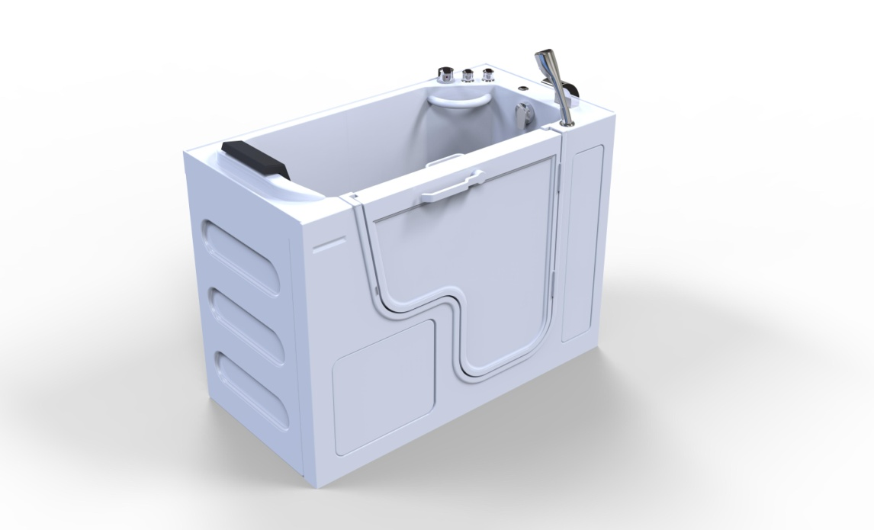

**Serenity Plus 66**

**Right Hand Shown**

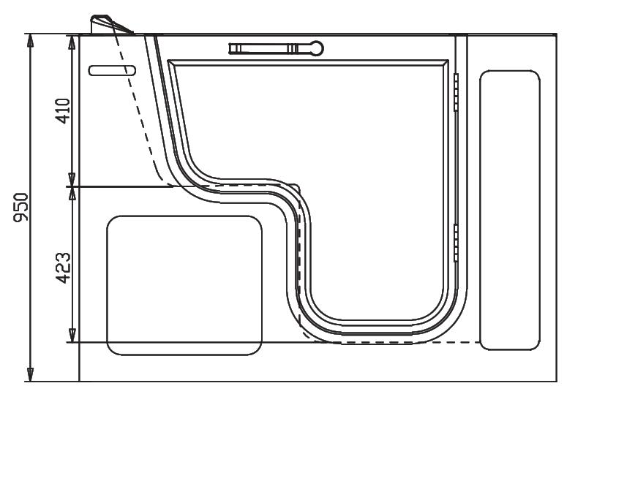

**Front View**

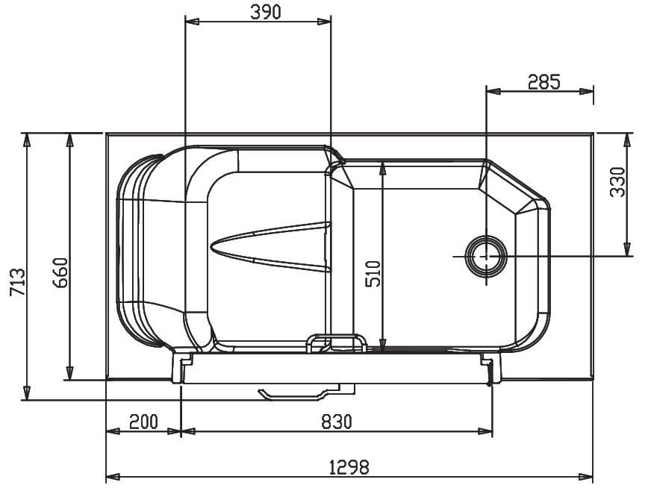

**Top View**